**Introduction to Linux**

**Exercise**

**Q**1: Create a directory "exercise" inside your home directory and create nested (dir1/dir2/dir3) directory structure inside "exercise" with single command.

**Ans1.** mkdir -p exercise/dir1/dir2/dir3

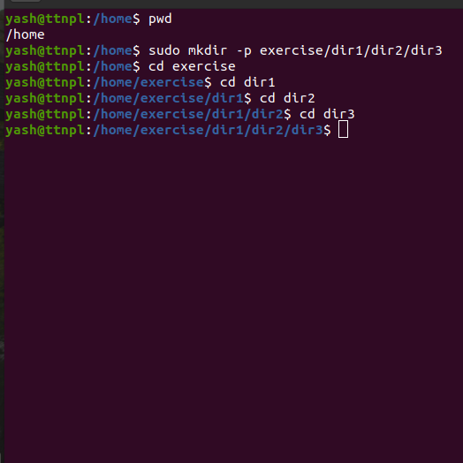

**Q2:** Create two empty files inside dir2 directory: emptyFile1, emptyFile2 in single command

**Ans2.** touch {emptyfile1.txt,emptyfile2.txt}

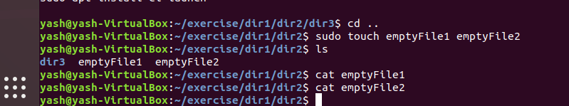

**Q3:** Create one file file1.txt containing text "hello world" and save it.

**Ans3:**

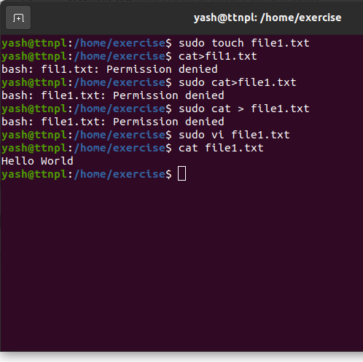

**Q4:** Find a "passwd" file using find command inside /etc. copy this files as passwd_copy and then rename this file as passwd_backup.

Ans4:

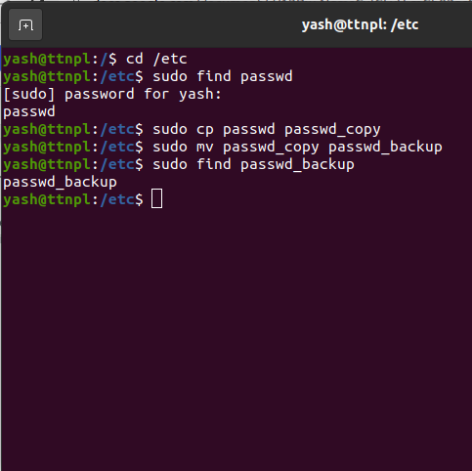

**Q5:** Try reading passwd_backup file in multiple tools: less,more,cat,strings etc and find the difference in their usage.

**Ans5:** less command

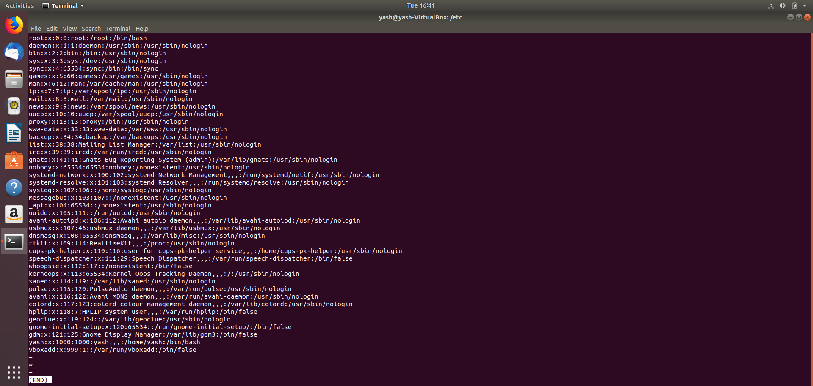

All the data are opened in the new page (like file is open in vim) and also we can use arrow keys for navigation of data. To quit from that page press q. When we come back to the bash there is only less command there. Displayed all the data at once.

**more command**

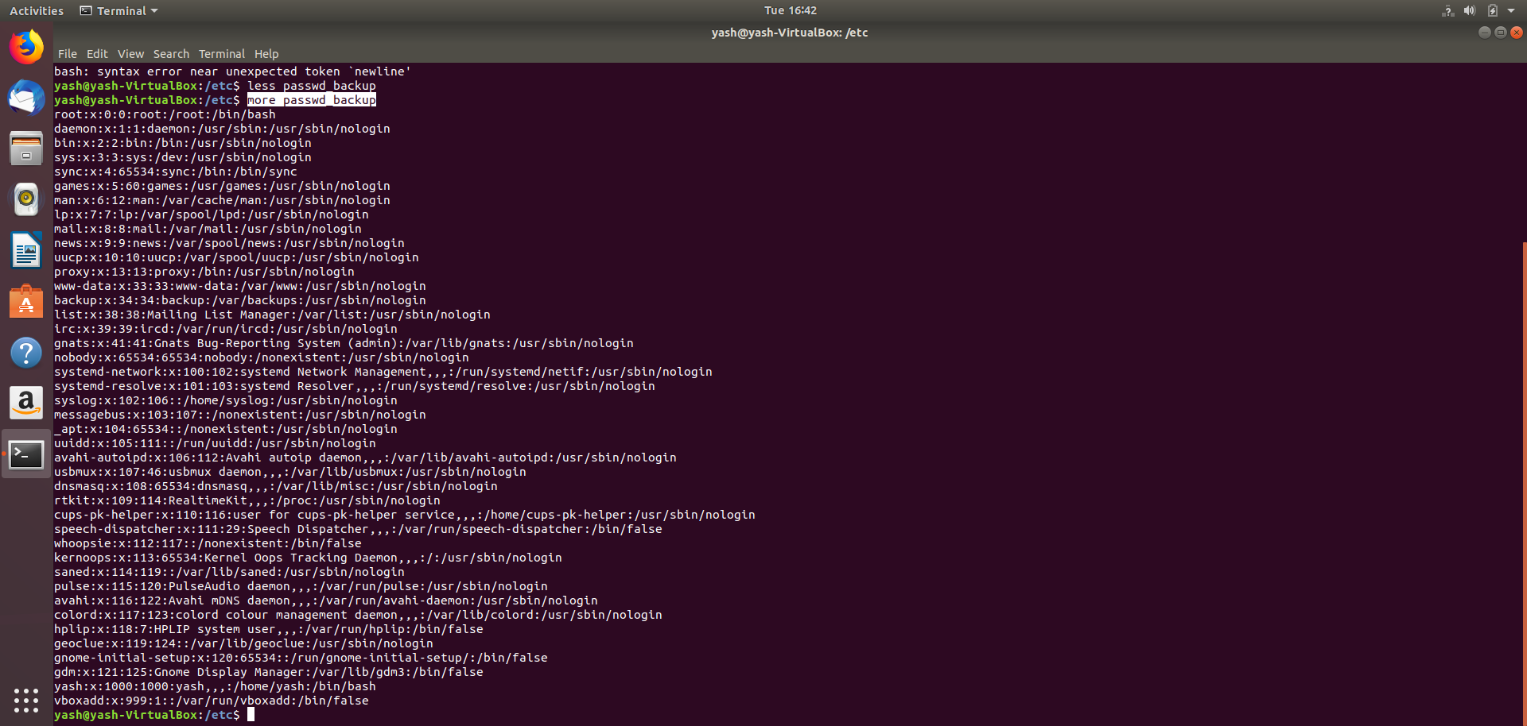

All the data displayed on same bash just after the command. Some part of data displays first after when we press Enter the following data is start displaying and you want to display all data at once press Space.

**cat command**

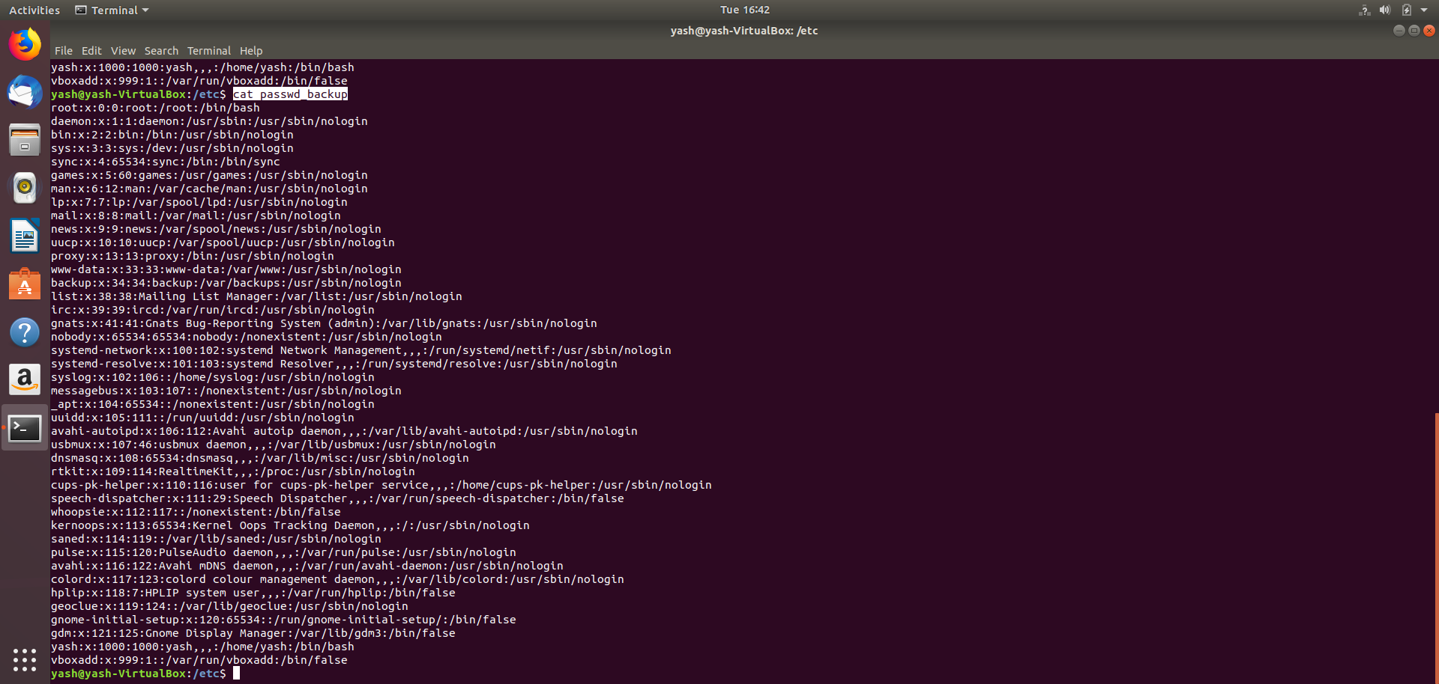

**TAIL: Reads last 10 lines**

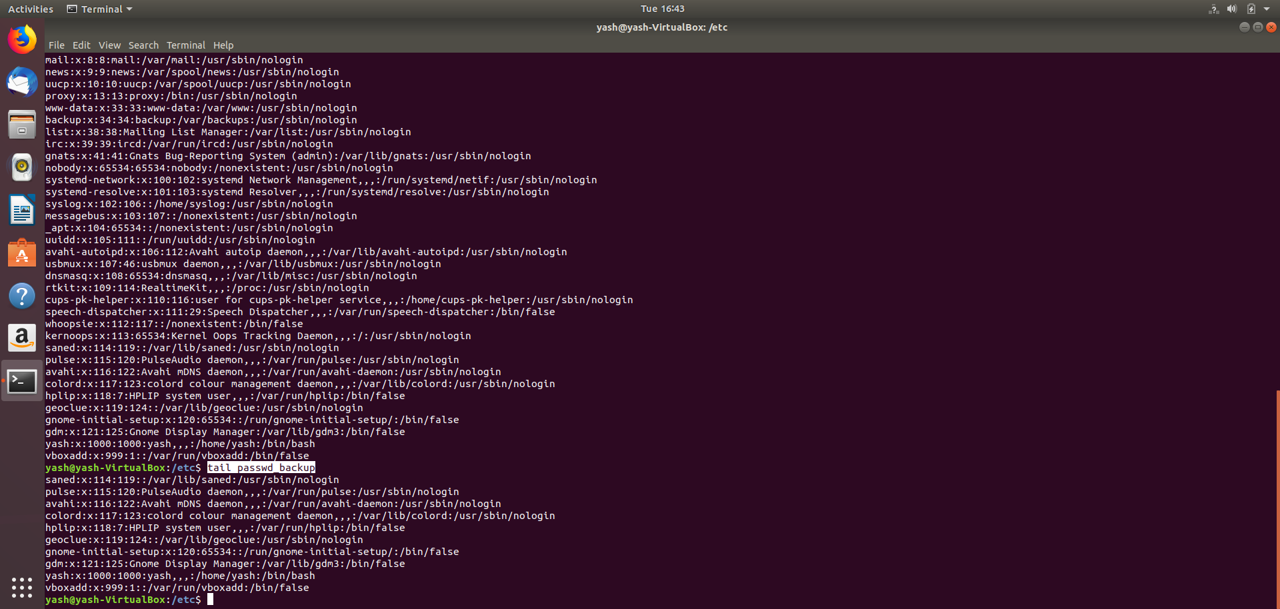

**HEAD:- Reads first 10 Lines**

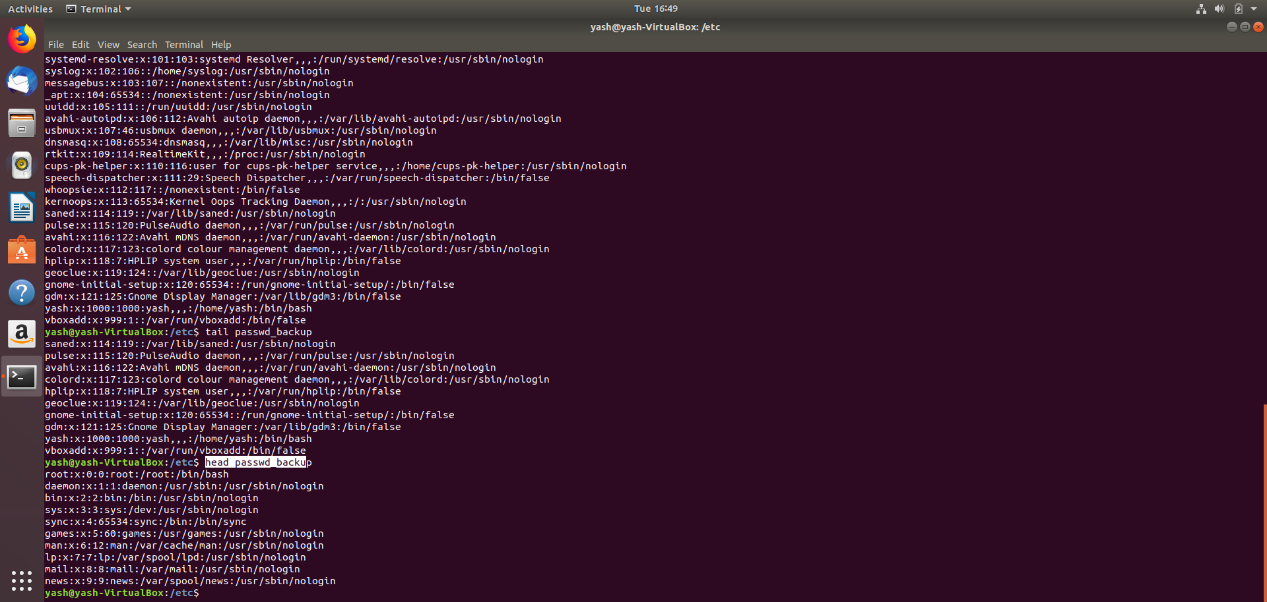

**Q6:** Find out the number of line in password_backup containing "/bin/false".

**Ans6:**  wc -l /bin/false

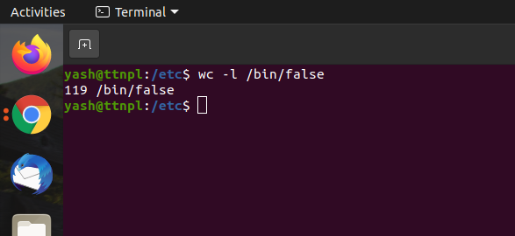

**Q7:** Get the first 5 lines of a file “password_backup” and  Redirect the output of the above commands into file "output".

**Ans7:** head -n 5 passwd_backup

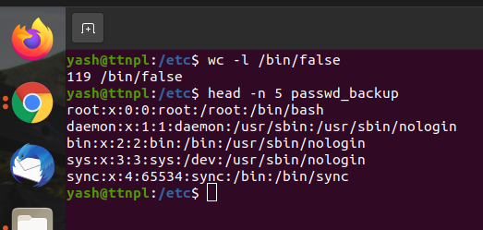

**Q8:** Create a "test" user, create its password and find out its uid and gid.

**Ans8:** sudo useradd test

sudo passwd test

id test

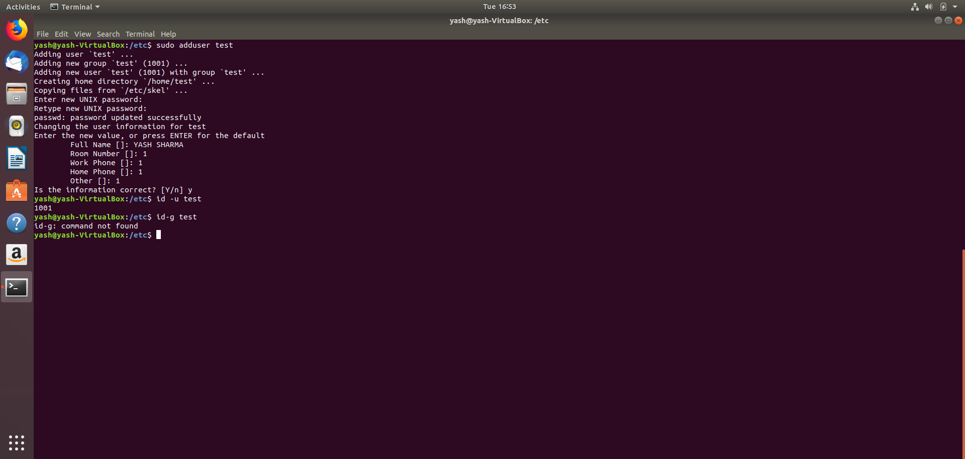

**Q9:** Change the timestamp of  emptyFile1,emptyFile2 which are exist in dir2.

**Ans9:** touch file1.txt

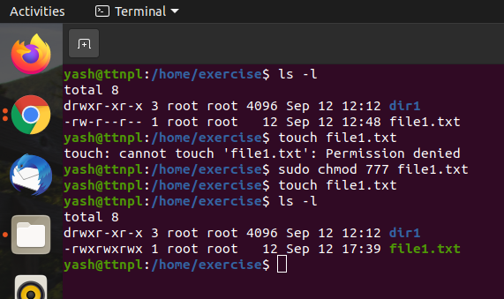

**Q10:** Login as test user and edit the "output" file created above. Since the permission won’t allow you to save the changes. Configure such that test user can edit it.

1. Add group owner of the "output" file as the secondary group of test user and check/change the "output" file permission if it is editable by group. Once done revert the changes
2. Make the file editable to the world so that test user can access it. Revert the changes after verification
3. Change the ownership to edit the file.

**Ans10:** 1. For changing the group chgrp command : sudo chgrp test output

It already have write permission for group test.

2. To make file editable to the world or other we use chmod command: sudo chmod o+w output

To revert it we use chmod command: sudo chmod o-w output

1. To change the ownership we use chown command: sudo chown test output

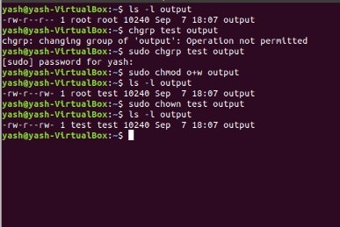

**Q11:** Create alias with your name so that it creates a file as "/tmp/aliastesting".

**Ans11:**

**Alias: Alias is a custom shortcut which you create for the commands which you use often to save time and be more efficient.**

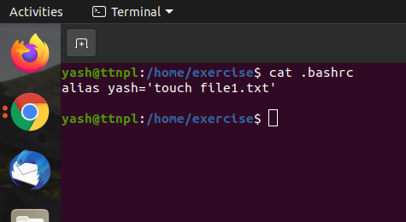

**Q12:** Edit ~/.bashrc file such that when you change to "test" user it should clear the screen and print "Welcome".

**Ans12:**

**Q13:** Install “zip” package.

**Ans13:** sudo apt-get install zip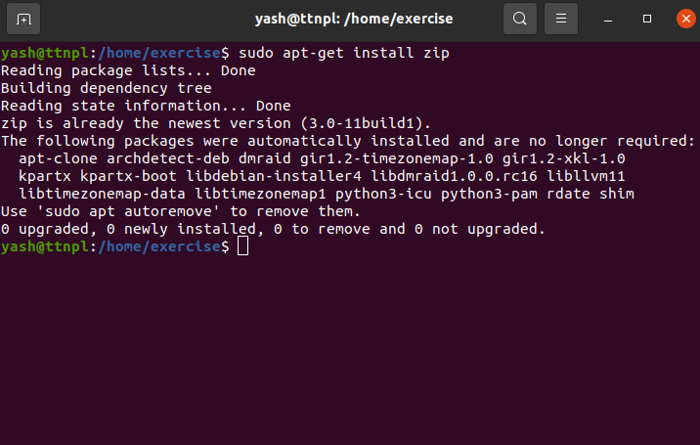

**Q14:** Compress "output" and "passwd_backup" files into a tar ball. List the files present inside the tar created.

**Ans14:**

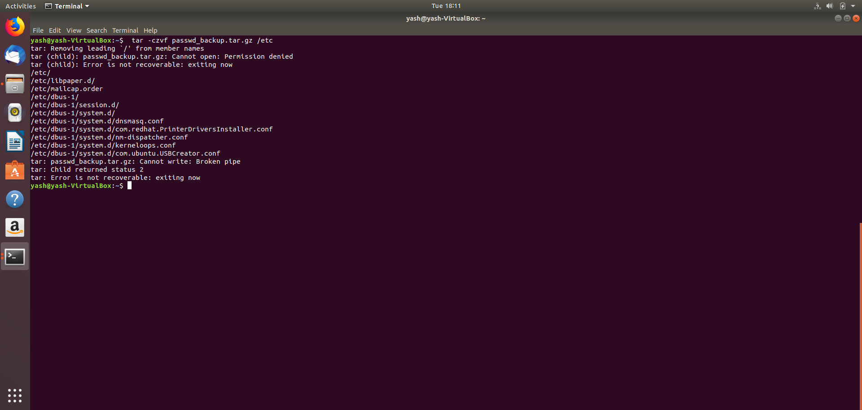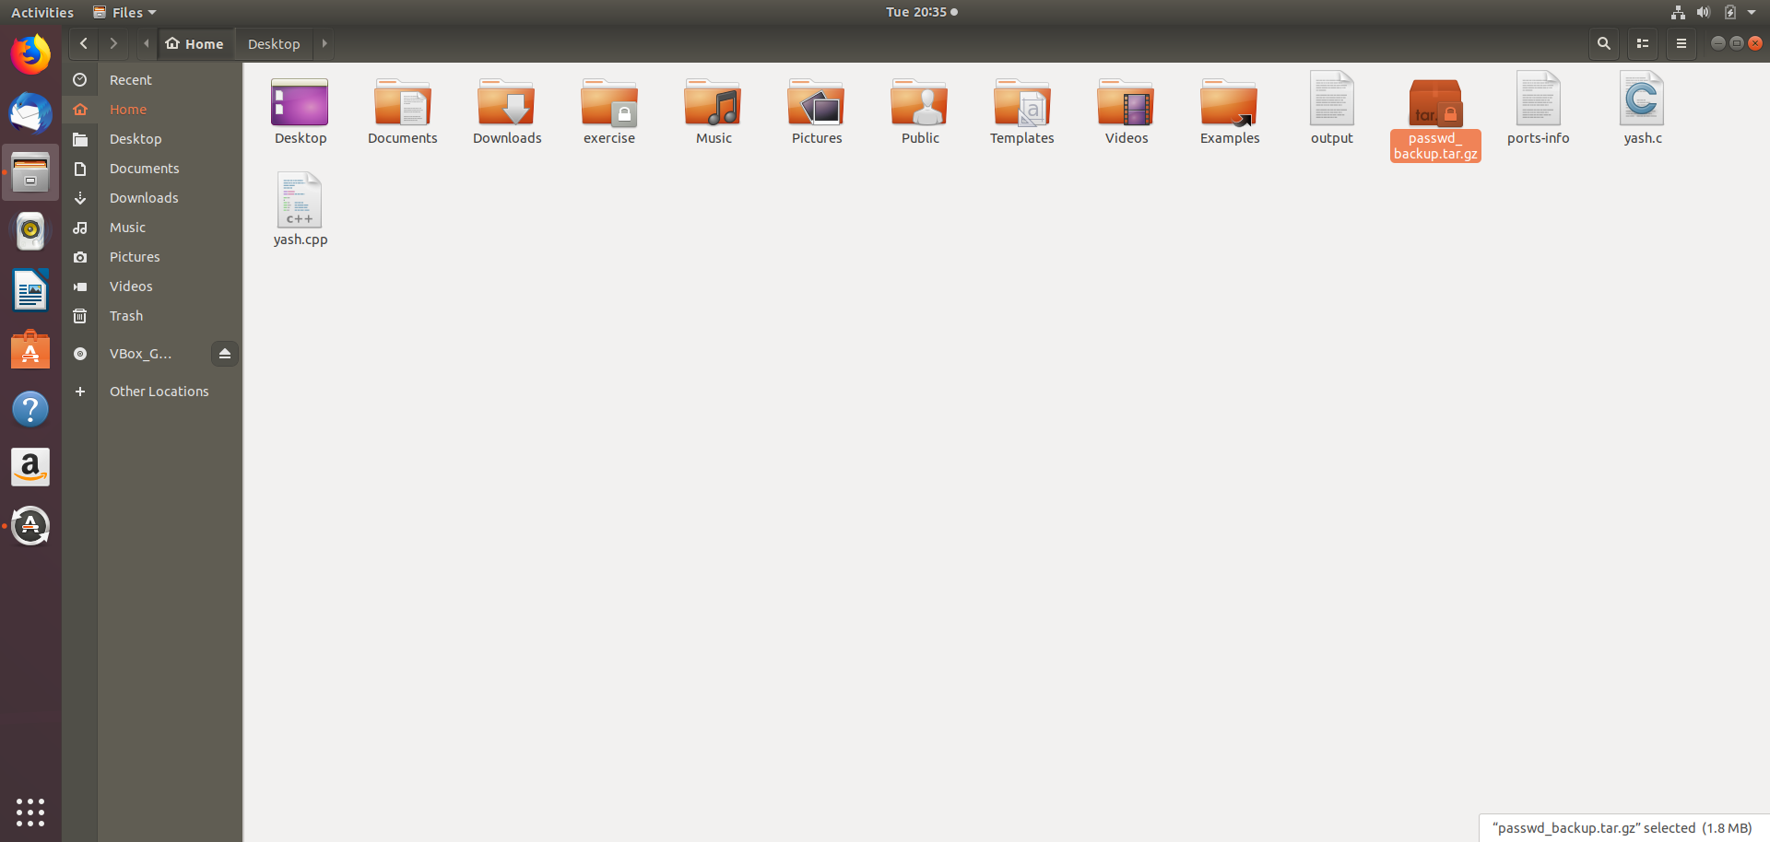

**Q15:** scp this file to test user.

**Ans15:**

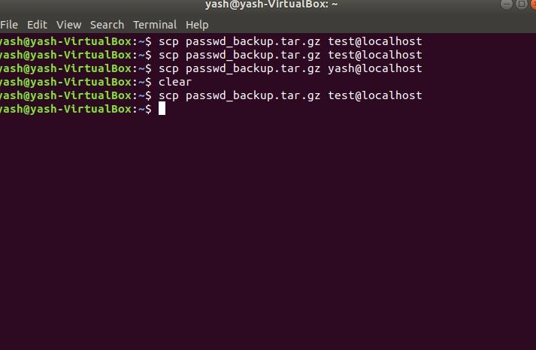

**Q16:** Unzip this tar bar by logging into the remote server.

**Ans16:**

**Q17:** Download any image from web and move to desktop

**Ans17:**

**curl** [**https://cdn.britannica.com/83/146383-050-62A38BCD/Green-tree-python.jpg**](https://cdn.britannica.com/83/146383-050-62A38BCD/Green-tree-python.jpg) **> photo.jpg**

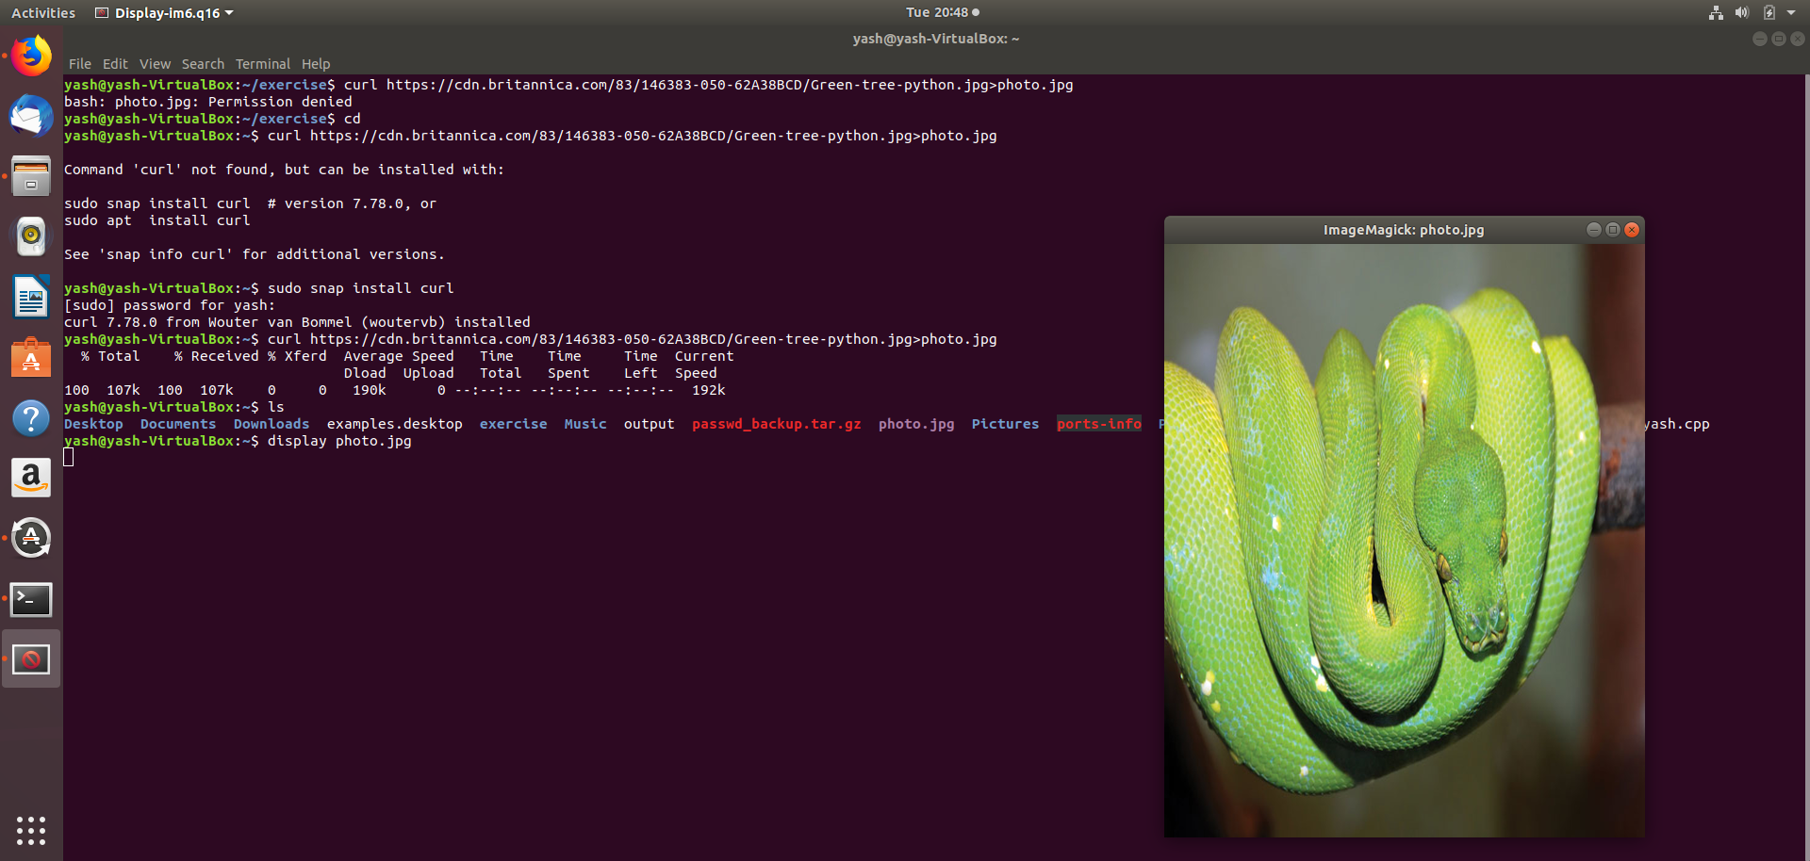

**Q18:** How to get help of commands usages.

**Ans18:** command --help

Also we can use man command to get manual of that command.

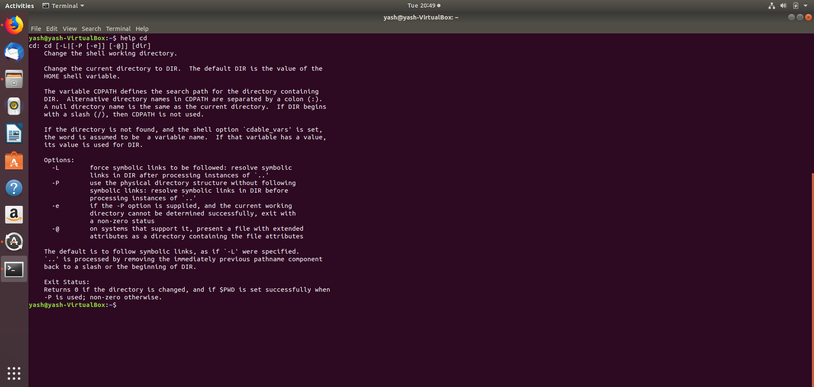

**Q19:** Create a symlink of /etc/services into /tmp/ports-info.**Ans19**

**ln -s photo.jpg symimage.jpg**

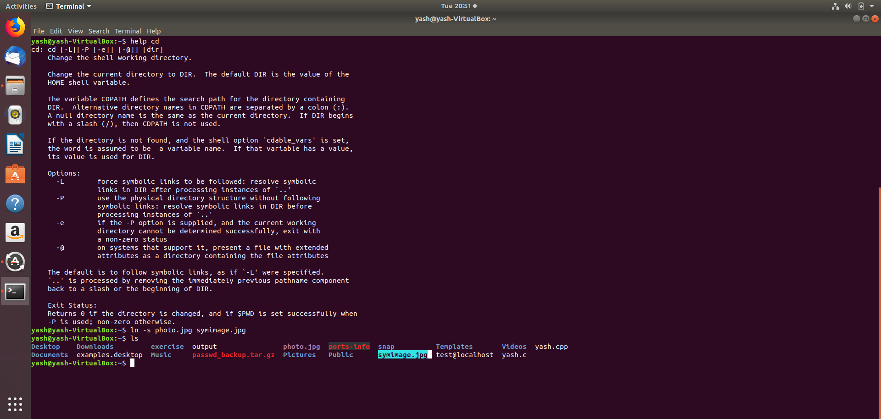

**Q20:** You are appointed as a Software/DevOps Engineer in ABC media services. On your first day you need to troubleshoot a problem. There is a command “xyz” somewhere installed in that Linux system. But as a new joinee you do not have any idea about where is that Installed. How can you check that?

**Ans20: which** commond is used.

